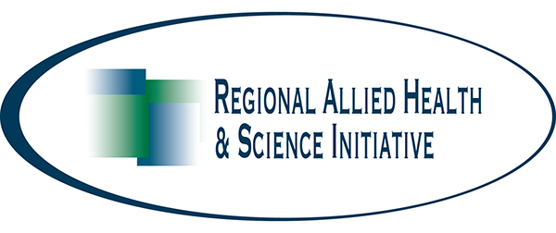
www.rahsi.org

How can I develop/improve a Health Career Pathway?

The process of implementing a Health Career Pathway varies by district and site. The best start is to decide: What you want to achieve by developing this program; who can help; foreseeable barriers or issues; and formulating a plan. If you have already started a program, please use this worksheet to refocus and improve your existing Health Career Pathway.

- What are/would be the goals of your program?

- Identify team members that could help you implement a Health Career Pathway:
Name Contact Information
Administrators
Counselors
Lead teacher/Coordinator
Additional Teachers/Staff
Industry Partners
(local clinics, hospitals, nursing facilities, etc.)
Financial support
(grants, site funds, etc.)

- What are some of the implementation issues/concerns that inhibit you from
creating and sustaining a successful Health Career Pathway program?

4. What are my next steps in implementing and/or growing a Health Career Pathway at my site (or in my district)?

5. How can we, the Regional Allied Health and Science Initiative, help you?

